# Practical No. 4

%Sanika Sandip Firke

%Roll No.31134

image1=imread('lena.png'); image1=rgb2gray(image1); mask1=(1/9)*[1 1 1;1 1 1;1 1 1];

mask2=(1/25)*[1 1 1 1 1;1 1 1 1 1;1 1 1 1 1;1 1 1 1 1;1 1 1 1 1]; mask3=(1/16)*[1 2 1;2 4 2;1 2 1]; image2=conv2(double(image1),double(mask1)); image3=conv2(double(image1),double(mask2)); image_w=conv2(double(image1),double(mask3));

image2=uint8(image2); image3=uint8(image3); image_w=uint8(image_w); subplot(4,1,1); imshow(image1); title('Original Image'); subplot(4,1,2); imshow(image2); title('Applying 3*3 Filter'); subplot(4,1,3); imshow(image3); title('Applying 5*5 Filter'); subplot(4,1,4); imshow(image_w);

title('Applying Weighted Filter');

title('Image after median filtering with 5*5'); **Output:**

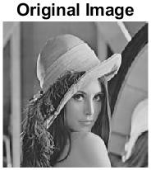

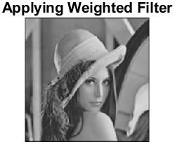

**Median Filter**

%Sanika Sandip Firke %Roll No. 31134

a=imread("C:\Users\kulso\Desktop\pepper.jpeg"); a=rgb2gray(a);

order=3; d=medfilt2(a); figure; subplot(2,2,1); imshow(d);

title('Original Image'); n=imnoise(a,'salt & pepper',0.1); subplot(2,2,2); imshow(n);

title('Image with 10% added noise of type salt n pepper'); d1=medfilt2(n,[3 3],'zeros'); d2=medfilt2(n,[5 5],'zeros'); subplot(2,2,3); imshow(d1);

title('Image after median filtering with 3*3'); subplot(2,2,4); imshow(d2);

title('Image after median filtering with 5*5');

